The Hanover Cultural Council
… wants to hear from you!

Please fill out the survey provided and deposit it here.

We are looking to set our priorities for the future and would like your feedback regarding programs you would like to see in our community and those we have sponsored in recent years. Your opinions and suggestions are important to us.

**There will be a public meeting at the John Curtis Free Library on Wednesday, December 6th, 2017 from 7:00-8:00pm in the Trustees Room, for those who wish to share ideas in person.**

We look forward to seeing you then!

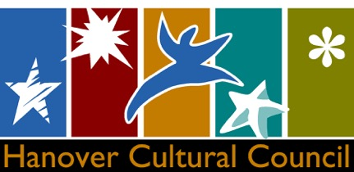

Thank you for your input. We will carefully consider your suggestions.
Karen Cass, HCC Chair
karencass@comcast.net

